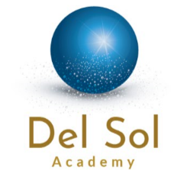
Del Sol Academy is a new STEAM school, currently under construction and scheduled to open fall 2018. Del Sol will serve students, grades TK-8, who live in the northwest region of the Jurupa Unified School District. STEAM refers to curriculum and learning experiences which develop one’s knowledge and competencies in the areas of science, technology, engineering, art and mathematics.
Mission Statement
From an early age, it is our mission to engage students in science, technology, engineering, art and mathematics, to ensure students recognize the value and applications of these content areas, while maintaining interest in STEAM related college and career pathways. Such efforts will ensure students are competitive in the global workforce, responsible global citizens, and equipped to handle global challenges.
School Motto:
STEAM for all between the bells.

Del Sol Academy will prepare students for future college and career goals by developing and implementing units of study taught through the lens of science. Curriculum will provide students with the opportunity to apply the arts while partaking in thematic, project based learning experiences which integrate technology, engineering, design, programming, inquiry, Common Core Stat Standards (CCSS) and Next Generation Science Standards (NGSS). Learning experiences will provide students with the opportunity to develop 21st Century Fluencies necessary for future jobs and global citizenship. Fluency skills include creativity; problem-solving; the ability to interpret and evaluate data; expressing ideas through artistic mediums; using media to receive and give information; and the capacity to successfully work, collaborate and interact with virtual and real partners.

Del Sol Academy will embrace a culture that values taking personal responsibility; understanding world-wide issues; respecting individuals & cultures; using digital resources responsibly; servant leadership; and environmental stewardship.

